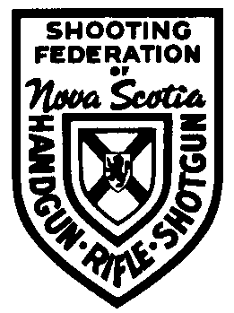
Shooting Federation of Nova Scotia

PO Box 28023

Dartmouth Nova Scotia

B2W 6E2
info@sfns.info

CLUB AFFILIATION AND MEMBERSHIP

For the Period April 2021 through March 2022

CLUB NAME: .

CLUB PRESIDENT: .
(Or Council Member Designate)

ADDRESS: .

.

POSTAL CODE: .

TELEPHONE: .

EMAIL ADDRESS: .

Club Mailing Address if Different From Above

ADDRESS: .

.

POSTAL CODE: .

Enclosed please find our cheque for $5.00 affiliation and $ for

members at $1.00 per member. Total of $ .

To help us better understand the structure of our membership base would you provide an estimate of your club membership age by the following categories:
Under 19 19 to 25 26 to 50 51 to 64 65 & Up

MALE _______ ______ ______ ______ ______

FEMALE _______ ______ ______ ______ ______

Please make cheques payable to the Shooting Federation of Nova Scotia.
Mail application with remittance to:

Shooting Federation of Nova Scotia

PO Box 28023
Dartmouth, NS

B2W 6E2

PLEASE REFER TO REVERSE SIDE FOR MORE INFORMATION

